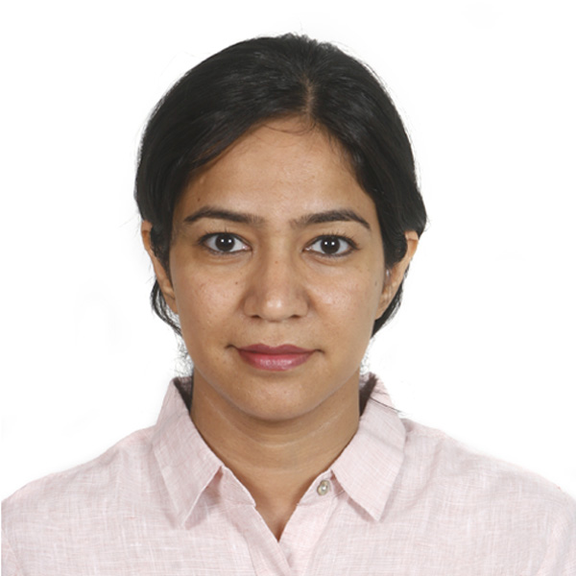
Curriculum Vitae
Nanda Samridhi, MD (Anaesthesia), EDRA
Date: 09/04/2021

Contact Information
Address: D-23, Akar Marg, Banipark, Jaipur, Rajasthan, India

Phone No: +91- 9680565399

E-mail: samridhinanda@gmail.com, samridhi.nanda@yahoo.in

Languages: English, Hindi
(IELTS 2017: Listening-8.5, Reading- 7.5, Writing-7.5, Speaking- 8.5, Overall- Band 8)

Graduate Education
Duration | Degree | Date awarded | Institution
1999-2005 | Bachelor of Medicine and Bachelor of Surgery (M.B.,B.S) | August, 2006 | University of Rajasthan

Postgraduate Education
Duration | Degree | Date Awarded | Institution
2006-2009 | Doctor of Medicine (MD), Anaesthesia | July 2009 | Rajasthan University of Health Sciences

Employment Details
- Sept 2019 to present. Associate Professor, Department of Anaesthesia,
Sawai Man Singh and attached group of Hospitals,
Jaipur, Rajasthan, India
- 2013 to Sept 2019 Assistant Professor, Department of Anaesthesia, Sawai man Singh and Attached group of Hospitals, Jaipur, Rajasthan, India
- 2011- 2013 Senior Resident Anaesthesia, Jai Prakash Narayan Apex Trauma Center, All India Institute of Medical Sciences
- Jan 2010- July 2010 Senior Resident Anaesthesia, Jai Prakash Narayan
Apex Trauma Center, All India Institute of Medical
Sciences

Certifications
- 2021 EDPM (European Diploma in Pain Management) Part 2
- 2020 Fellow in Pain Medicine (AIIMS, New Delhi)
- 2019 EDPM (European Diploma in Pain Management) Part 1
- 2018 EDRA (European Diploma in Regional Anaesthesia) Part 2
- 2015 EDRA (European Diploma in Regional Anaesthesia) Part 1
- 2013 ACLS Provider
- 2012 ATLS Instructor
- 2011 Essentials of Palliative care, Indian association of Palliative Care
- 2011 ECFMG Certification

Medical Licensures
- 2012 United States Medical Licensing Examination (USMLE)
- 2009 Delhi Medical Council (Active)
- 2006 Rajasthan Medical Council (Active)

Honors and Awards
Year | Award/Honor | Institution | Nature of Award
2013 | Tenth Rank | Rajasthan Public Service Commission | Associate Professor in Department of Anesthesia at SMS Hospital, Jaipur
2011 | First Rank | All India Institute of Medical Sciences | First rank in selection process (Examination and personal interview) for the post of Senior Resident at All India Institute of Medical Sciences
1999 | Ninth Rank | Pre medical entrance examination | Ninth Rank in State wide entrance examination for medical schools

Research Experience
2006-2008 – Thesis (MD, Anes.) – “Supraclavicular Brachial Plexus Block: A comparison of effect on onset and duration of anesthesia by using Morphine, Verapamil as adjuncts and in combination with Lidocaine”

Publications
- Nanda S, Gupta A, Kulshreshta A, Kalra P, Sharma M. Anesthetic Management
of a 137-year-old patient with fracture neck of femur. JOACP. 2012; 28(1): 143
- Sahoo S, Kaur M, Tripathy HK, Kumar A, Kohli S, Nanda S. Comparative evaluation of midazolam and clonidine as pediatric oral premedication. Anesth Essays Res 2013;7:221-7
- Kumar A, Sinha C, Goyal K, Nanda S. A rare complication of mandibular surgery: Something to chew on! J Anaesthesiol Clin Pharmacol 2013;29:264
- Nanda S, Sawhney C, Sinha C. In response to: Midazolam-induced acute dystonia reversed by Diazepam. J Anaesthesiol Clin Pharmacol J Anaesthesiol Clin Pharmacol 2013 Apr;29(2):268-9
- Kundal R, Bharadwaj A, Dogra N, Jain P, Nanda S, Kundal VK. Anaesthetic Management of Unexpected Subglottic Stenosis in a Neonate with Tracheoesophageal Fistula. Journal of Case Reports 2013;3(2):217-219
- Gupta D, Chatterjee R, Nanda S, Dutt A. Anaesthetic Management of Unexplained Thrombocytopenia. Journal of Case Reports 2015;5(2):470-472
- Yadav N, Ayub A, Garg R, Nanda S, Gupta B, Sawhney C. Sonographic assessment of predictors of variation in depth of corner pocket for ultrasound guided supraclavicular brachial plexus block. J Anaesthesiol Clin Pharmacol 2016;32:25-28

Scholarships

- International Assembly of Pediatric Anesthesia 2012- scholarship worth 2500 USD and opportunity to attend and present poster on “ A double blind randomized trial comparing two concentrations of Bupivacaine with or without Clonidine as adjuvant in caudal epidural block in pediatric patients.”

Presentations
- 2008 Podium presentation- Supraclavicular Block: adjuncts to Lidocaine for improving the onset of Anesthesia and Analgesia at ISACON-2008 (National conference of Indian Society of Anesthesia held at Jodhpur, India).
- 2012 Poster presentation- A double blind randomized trial comparing two concentrations of Bupivacaine with or without Clonidine as adjuvant in caudal epidural block in pediatric patients at IAPA 2012, Washington DC, USA
- 2013 Poster presentation- Sonographic assessment of predictors of variation in depth of corner pocket for ultrasound guided supraclavicular brachial plexus block: A Volunteer based crossectional observational study at 12th annual symposium of NYSORA, New York, USA
- 2015- National Speaker-Supraglottic devices are not safe for use in Obstetric Anaesthesia- Pro. Debate as faculty speaker at ISACON 2015, Jaipur, Rajasthan, India
- 2017- National Speaker. Neurological examination in Chronic Pain as a faculty speaker. ISSPCON 2017; Jaipur, Rajasthan, India
- 2018- National Speaker. Basics of Ultrasound guided blocks. National Faculty, ISSPCON 2018, New Delhi, Delhi, India
- 2018- National Speaker .Web based Medical Education-Con. National Faculty, RSACPCON 2018, Jaipur, Rajasthan, India
- 2019- Poster presentation. ESRA 2019. Effect of 15 ml of 0.5% Ropivacaine on onset of sensory anaesthesia in Costoclavicular approach of Infraclavicular Brachial Plexus: a case series
- 2019- Poster presentation- ESRA 2019. Effect of Preoperative gabapentin on intraoperative and postoperative pain in paediatric urogenital surgeries: A randomized controlled trial.
- 2019- National Speaker- Association of Minimal Access Surgeons of India (AMASI skill Course & FMAS Examination). Anaesthesia for Laparoscopic Surgery

Professional Society Membership
- 2009 Life member, Indian Society of Trauma and Acute Care (ISTAC)
- 2013 Life member, Academy of Regional Anaesthesia( AORA)
- 2015 Life Member, Indian Society of Anaesthesia (ISA)
- 2015 Member , European Society of Regional Anaesthesia (ESRA)
- 2017 Life Member, Indian Society of Study of Pain (ISSP)
- 2018 Member, World Institute of Pain (WIP)
- 2021 Life Member, Indian Society of Pain Clinicians (ISPC)

Conferences and workshops attended
- 2019 Cadaveric hands on workshop on Chronic Pain at ESRA 2019 at Bilbao, Spain.
- 2019 Cadaveric hands on workshop in chronic pain, ISSPCON 2019, Bengaluru, Karnataka, India
- 2018 Advanced blocks in Chronic Pain. ISSPCON 2018, New Delhi, Delhi, India
- 2017 Cadaveric Hands on workshop on Anatomy of Upper Limb and Lower Limb at ESRA 2017. Lugano, Switzerland
- 2016 Cadaveric hands-on workshop on Regional Anaesthesia at AIIMS Ultrasound Workshop, Jodhpur AIIMS
- 2015 3rd Sg- Duke Conference held at Singapore, Singapore
- 2015 Ultrasound in Regional Anaesthesia at 3rd Sg- Duke Conference (workshop)
- 2013, 12th Annual Symposium of NYSORA at New York, USA
- 2013, 3rd national conference AORA, Pune, Maharashtra, India
- 2013 Workshop on Pediatric Regional Anaesthesia at AORA, Pune, Maharashtra, India
- 2012, IAPA, held at Washington DC
- 2012 Workshop ultrasound guided pediatric regional Anaesthesia at IAPA
- 2012, ASA, held at Washington DC
- 2012, 2nd ICIPM, held at AIIMS.
- 2011 7th WINFOCUS world congress on Ultrasound in emergency and Critical
Care
- 2009 “Trauma-2009” Held at Jai Prakash Narayan Apex Trauma Center, AIIMS
- 2009 CWRPM, Annual conference on Pain, SMS Hospital, Jaipur
- 2008 CWRPM, Annual Conference on Pain, SMS Hospital, Jaipur
- 2008 ISACON, Annual Conference of Indian Society of Anaesthesia
- 2006 CME, Critical Care Management, SMS Hospital, Jaipur

Personal attributes:
I am ambitious and hardworking, with a zeal for learning and the will to pursue my goals. I believe completely that no feat is unachievable and that no task is unworthy. I am known for my excellent communication skills and ability to excel both as a team member and a team leader, which is a necessity for optimal patient care. I recognize my limitations and constantly try to overcome them by analyzing my actions and taking guidance from learned colleagues.

Referees:
Dr Reema Meena
Professor and Head of Department,
Sawai Man Singh & Attached group of Hospitals,
Jaipur, Rajasthan
Ph- 0141-2518680
Email- reemadrrn@gmail.com

Dr Kanchan Chauhan

Professor, Department of Anaesthesia,
Sawai Man Singh & attached group of Hospitals,
Jaipur, Rajasthan
Ph- 8107872222
Email-kanchan2371@yahoo.com

Dr Mamta Khandelwal,

Professor, Department of Anaesthesia,
Sawai Man Singh & attached group of Hospitals,
Jaipur, Rajasthan
Ph- 9929338174
Email-drmamtakhandelwal@gmail.com

